# Analytics: BTF Altered Calling Criteria



* Click on **Analytics** tab in Powerchart Organiser toolbar.

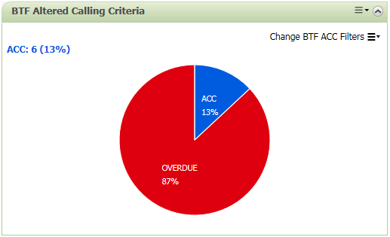

* Locate the BTF Altered Calling Criteria.
* When the page first loads, the pie chart displays all documented ACC records for the facility. Hover the cursor to see more information.

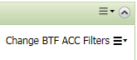

* Click on **Change BTF ACC Filters menu** to expand the fitters.

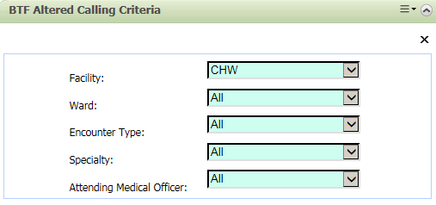

* Update any fitlers as required.
* The Pie chart will populate with the new data.
* Click on any slice in the pie chart to display the list of patients qualified according the selected filters.

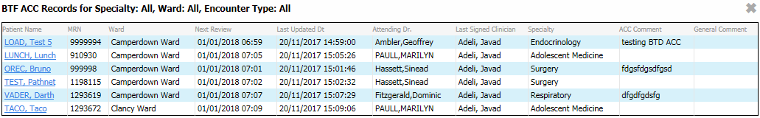

* Click on any Patient’s name to open up patient’s BTF observation chart page.

Or

* Click away on the page to close the list.